Name: Mansvi Kumar
Rollno: 5
Regno: 12309317
Section: k23dx
INT-222

Code:
import express from "express";

const app = express();
const port = 3000;

function databaseQuery(id) {
return new Promise((resolve, reject) => {
setTimeout(() => {
console.log(`fetching id: ${id}`);
}, 2000);
if(id == 101) {
resolve({id: 101, product: 'Laptop', price: 1000});
} else {
reject('Product not found');
}
})
}

app.use(express.json());

app.get("/product/:id", async (req, res) => {
try {
const response = await databaseQuery(req.params.id);
res.json(response);
} catch (err) {
res.status(404).json(err);
}
});

app.listen(port || process.env.PORT, () => {
console.log(`server is running at http://localhost:${port}`);
});

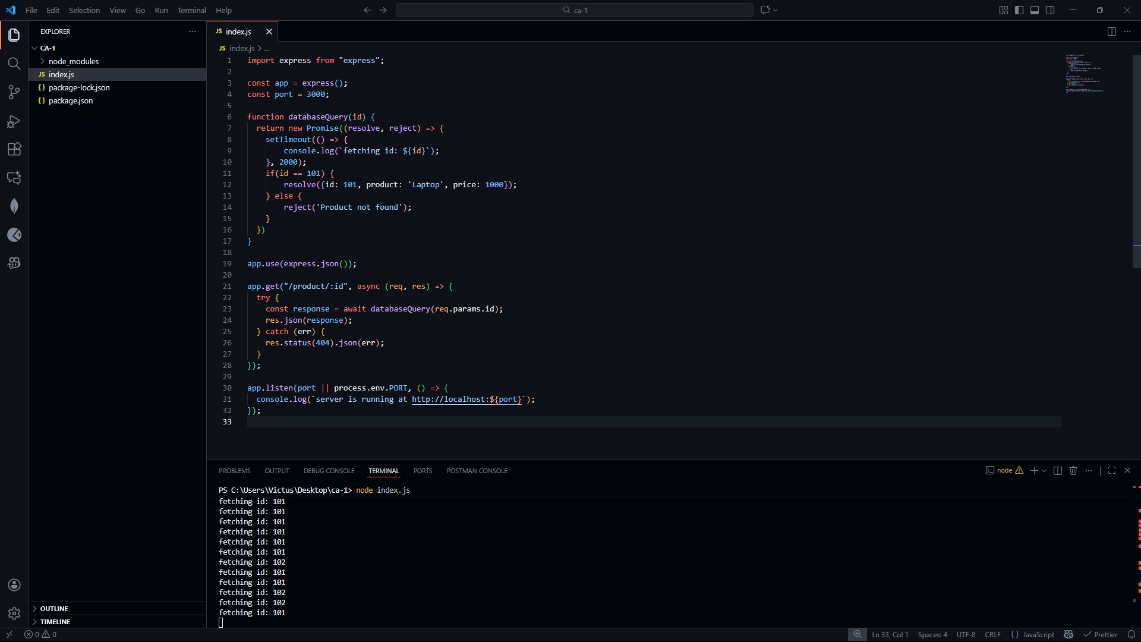

Code output:

